## horizontal line

Smart Farming

05.09.2022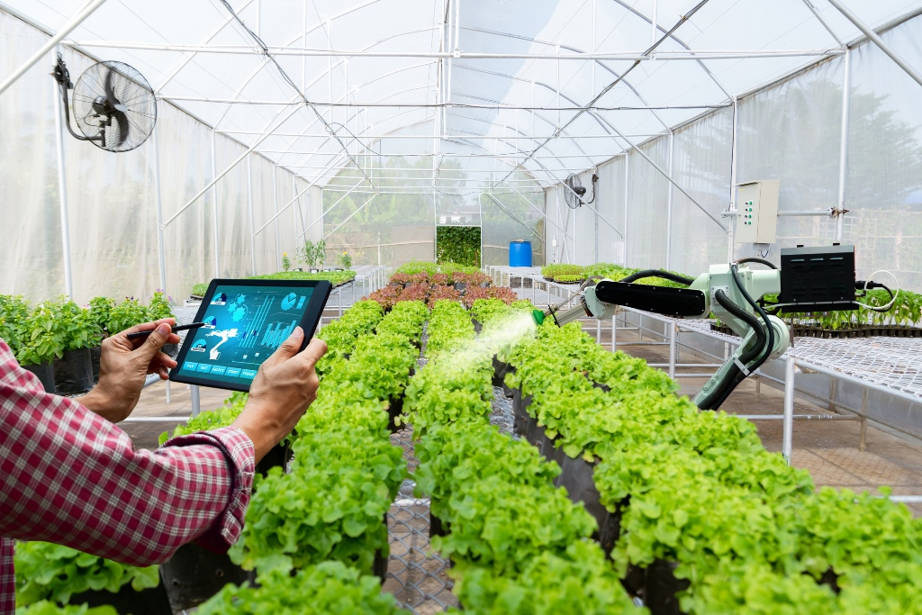

**─**

Team members:

Uditi Das - 21BCS225

Jyotsna Telgote - 21BCS221

Shreya Singh - 21BCS195

# Introduction

In the last decades, there has been a quick advancement in smart agricultural systems.In the past, irrigation systems used to be dependent on the mills to irrigate the farm by the conventional methods without knowing the appropriate quantities of these crops. Efficient systems should be proposed to minimize the water wastage.Our goal in this project is to help the farmers with their crop yields by using efficient methods for helping them during droughts and floods , decreasing the workload for the farmers on a day to day basis.

This Project Smart Farming system using Arduino UNO will use different sensors which will keep track of the crop condition which will ensure good production. We will also add a feature of an automatic Water pump system which will trigger water supply automatically by checking the moisture level of the crop and system automatically checks the moisture content and turns the water supply off when moisture is proper. We will also add a Ph Sensor, Temperature Sensor, Humidity Sensor, Sunlight Intensity and Air Quality Index sensor to check the overall condition of the crop.

# Components

1. Arduino UNO
2. Temperature Sensor
3. Moisture Sensor
4. Humidity Sensor
5. Ph Sensor
6. Water Pump
7. Motor
8. Water Pump Controller
9. GSM
10. Jumper wire.
11. 5V Battery
12. Liquid Crystal Display.

# Architecture

Our project will take measurements from the environment with the help of sensors connected at all times, which will record the values and pass them to Arduino. The Arduino will give instructions to other components accordingly to adjust the environmental parameters which are optimal for the Plant growth.

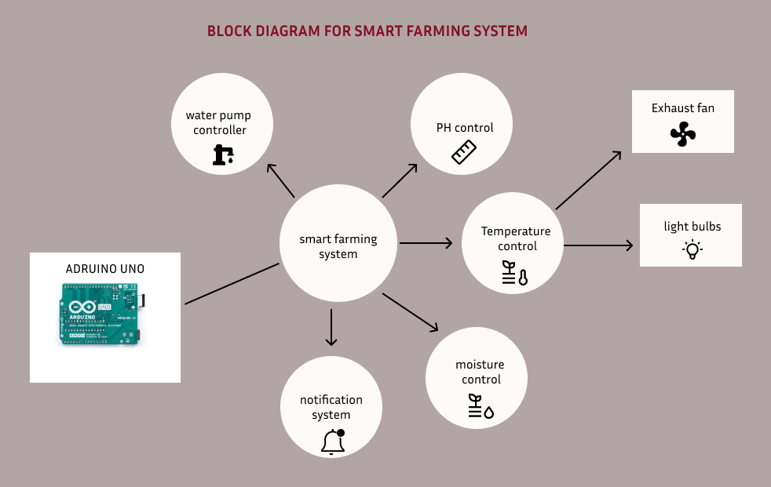

# Applications

## Sensors

➤ **Temperature Sensor :** DHT11 sensor will measure the temperature of the climate.

➤**Humidity Sensor :** DHT11 sensor will measure the humidity of the crop .

➤**Moisture Sensor:** Sensor will measure the moisture level of the soil.

➤**ph Sensor:** This will measure the acidity of the soil thus would help the user to know about the perfect fertilizer.

➤**Sunlight Intensity Sensor :** LDR will measure the Sunlight Intensity.

➤**Air Quality Index Sensor :** MQ135 Sensor will measure the AQI of the environment.

## Water Pump

When the moisture level of the soil falls below a certain level, The Water pump will trigger the water supply to automatically turn on, and after reaching a certain level it will turn off when moisture supply is proper. Moisture level of the soil will be measured by a moisture sensor.

## Water Spray

When the relative humidity measured with the help of a humidity sensor will fall below 50, then the water spray will turn on, it will also turn on when the temperature rises above 20 degree celsius.

## GSM Technology

Integration of the GSM module to the Arduino will help us achieve real time updates on the condition of the plot of the land such as when the Ph and moisture content of the soil is not optimum users will be warned through notifications.

## LCD

This will be used to show all the readings that will be taken from the sensors to show the overall condition of the crop. Weekly reports of crop condition and health will be shown.

## Exhaust Fan

An exhaust fan will be used to increase the airflow of the Greenhouse. This contributes to controlling both the temperature and humidity of the air.

## Light Bulbs

We will use bulbs to control the temperature when the temperature falls below 15 degree celsius.